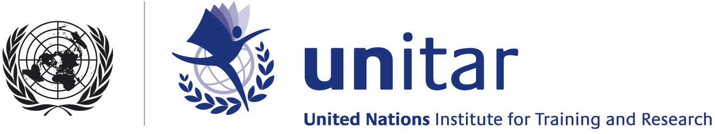

STATEMENT
GLOBAL PLATFORM FOR DISASTER RISK REDUCTION
GENEVA, 16-19 JUNE 2009

Distinguished participants and colleagues,
The United Nations Institute for Training and Research (UNITAR) is very pleased to take part in this important event. The Institute considers Disaster Risk Reduction as a central set of principles and guidelines of great importance in all the main goals of the global agenda for sustainable development, and an imperative for the welfare of people at risk worldwide.
Over the years, since its membership in the ISDR Inter-Agency task Force for Disaster Reduction, UNITAR has followed attentively and contributed actively to the implementation of disaster reduction and to the elaboration of the principles contained in the Hyogo Framework for Action. Here today we are witnesses of a collective effort to translate these principles into concrete action at all levels. UNITAR is committed to participating in this endeavour with its competencies and skills, by integrating disaster reduction principles in our own action as well as to serve as a conduit towards our constituency and our beneficiaries worldwide. The Institute trains tens of thousands of professionals each year in a vast range of disciplines, some of which have a strong connect with the goals of disaster risk reduction.
In the area of Climate Change, the Institute operates with the belief that adapting to climate change in a coherent and responsible manner means also building a sound basis for disaster reduction at local and systemic level. Under UNITAR leadership a “One UN Training Service Platform for Climate Change” is being shaped, which supports and seeks to scale the offer by UN agencies of coordinated training and skills development. In the words of the Director of Environment and Energy at UNDP: “The Platform is a concrete example of the UN Delivering as One and a practical contribution to coordinated UN training efforts in countries to strengthen capacities in the area of climate change”.
Similarly, UNITAR applies the skills of its Local Development Programme to make sure communities at risk become equipped with methodologies and tools that take full account of the importance of integrating disaster reduction into local territorial planning.
In the area of satellite technology, UNITAR together with the European Space Agency contributed to the adoption of concrete language at the International Conference on Disaster Reduction in Kobe, in 2005. This found its way into the Hyogo Framework for Action which now guides our collective endeavours. Through our Programme UNOSAT we remain committed to providing satellite solutions and training where it could best serve the goals of Disaster Risk Reduction, while coordinating with all operational Agencies and taking stock of the policy role of the UN Office for Outer Space Affairs.
UNITAR operates also in the areas of governance, peace and diplomacy, and environment, which are all linked to disaster reduction. Through our partnership networks we assemble a vast array of knowledge and skills ranging from academia, to science and technology and, equally if not more important, indigenous and traditional knowledge and practices.
This system of knowledge and its vast audience of beneficiaries are meant to advance the main goals of the international community by transferring knowledge where it is needed the most. Among these goals, the Institute recognises and supports wholeheartedly that of Disaster Risk Reduction. With this statement UNITAR wish to renew its commitment to this global cause and reassure the disaster reduction community and all peoples exposed to risk and vulnerability of our continuing attention and professional commitment.
Thank you

UNITAR – www.unitar.org

